 |  | 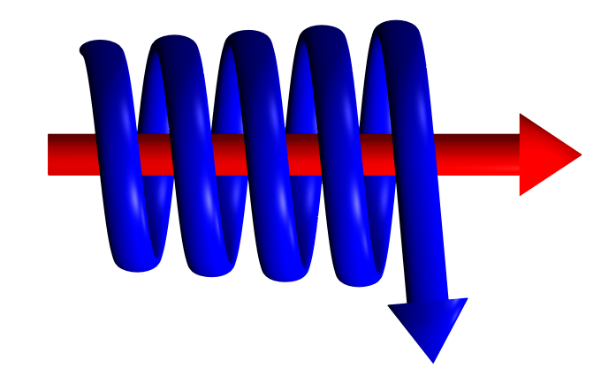
CYCLONE STEAM SEPARATOR - ENQUIRY FORM

In order for Kelburn Engineering Limited to supply a fully detailed quotation, please supply as much information as possible, clearly stating the units of measurement. Items marked with “*” must be completed for a fully detailed quotation.

Customer Name: (*)
Customer Address: (*)
Contact Name: (*)
Contact Position:
Contact Telephone No:
Contact Fax No:
Contact Email Address: (*)
Steam Mass Flow:(*)
Steam Operating Pressure:(*)
Steam Operating Temperature:(*)
Pipeline Size/Flange Rating: (*)
Material of Construction:
Design Pressure:
Design Temperature:
NDT Requirements:
Other Information:

